# PYTHON WORKSHEET – WORKSHEET 4

## Q1 to Q8 have only one correct answer. Choose the correct option to answer your question.

1. Which of the following function is used to determine the length of a string in python?
   1. length() B) len()

C) strlen() C) stringlen()

**Ans. B) len()**

1. Python is?
   1. compiled B) interpreted

C) compiled then interpreted D) none of these

**Ans. B) interpreted**

1. What will be the output of the following? a = [1,2,3,2,1]

a.pop(2) print(a)

A) [1,3,2,1] B) [1,2,2,1]

C) [1,2,3,1] D) [1,3,1]

**Ans. B) [1,2,2,1]**

4. If alist = [10,20,30,40,50,60], then alist[ : : -3] = ?

A) [40,30,20,10] B) [30,20,10]

C) [60,30,10] D) [60,30]

**Ans. D) [60,30]**

1. Which of the following will give the reverse of list ‘a’: A) a[-1:0] B) a[-1:-4]

C) a[ : :-1] D) a[0:-1:-1]

**Ans. C) a[ : :-1]**

1. If a = True, b = False and c = True. Then what will be the output of following code:

if not a or b: print("Eena")

elif not a or not b and c: print("Meena")

elif not a or b or not b and a: print("Deeka")

else:

print("Domniqaa")

* 1. Eeena B) Meena

C) Deeka D) Domniqaa

**Ans. B) Meena**

1. What is the output of the following?

print([x+y for y in [“Hello ”, “Adios ”] for x in [“World ”, “Python ”]])

* 1. [“Hello World ”, “Hello Python ”, “Adios World ”, “Adios Python ”]
  2. [“Hello World ”, “Adios World ”, “Hello Python ”, “Adios Python ”]
  3. [“World Hello ”, “Python Hello ”, “World Adios ”, “Python Adios ”]
  4. [“World Hello ”, “World Adios ”, “Python Hello ”, “Python Adios ”]

**Ans. C) [“World Hello ”, “Python Hello ”, “World Adios ”, “Python Adios ”]**

1. Str1 = “Hello Python”. What will be the output of : print(str1.find(‘o’)) A) 4 B) 4,10

C) 5,11 D) 5

**Ans. A) 4**

## Q9 and Q10 have multiple correct answers. Choose all the correct options to answer your question.

1. Which of the following is(are) correct method(s) to join two lists l1 and l2?
   1. l1+l2 B) l1.append(l2)

C) append(l1,l2) D) l1.extend(l2)

1. s = “pyworld”. Select all of the following which give same results? A) s[0]+s[-1] B) s[ : : -1][-1] + s[len(s)-1]

C) s[ : : -6] D) s[ : : -1][ : : -6]

**Ans. A) s[0]+s[-1], B) s[ : : -1][-1] + s[len(s)-1], D) s[ : : -1][ : : -6]**

## Q11 to Q13 are subjective questions, answer them briefly

1. Differentiate between a compiler and an interpreter? Which of them is used in python language?

Ans. Compiler transforms code written in a high-level programming language into the machine code, at once, before program runs, whereas Interpreter coverts each high-level program statement, one by one, into the machine code, during program run.

Python language uses the **Interpreter**.

1. What is the purpose of PYTHONPATH environment variable?

Ans. It is used to set the path for the user-defined modules so that it can be directly imported into a Python program. It is also responsible for handling the default search path for Python Modules. The PYTHONPATH variable holds a string with the name of various directories that need to be added to the sys.path directory list by Python.

1. How will you remove all the leading and trailing whitespaces in a string in python? Give one example.

Ans. Python String **strip()** function will remove leading and trailing whitespaces.

Example:

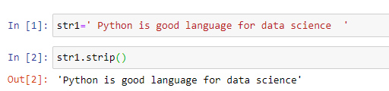

## Q14 and Q15 are programming questions. Answer them in Jupyter Notebook.

1. Write a python program to represent a user entered number in expanded form. For eg: user_input = 12345

Output = 1*10000 + 2*1000 + 3*100 + 4*10 + 5*1

Ans. 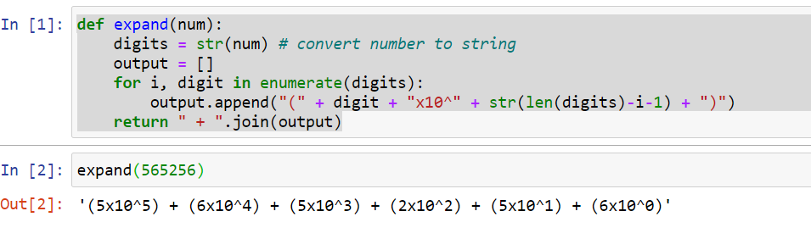

1. Write a python program to determine whether the number entered by the user is an Armstrong number or not?

Ans. File also uploaded on Github Account.

